#
# 20190807
# Was follow task.
#

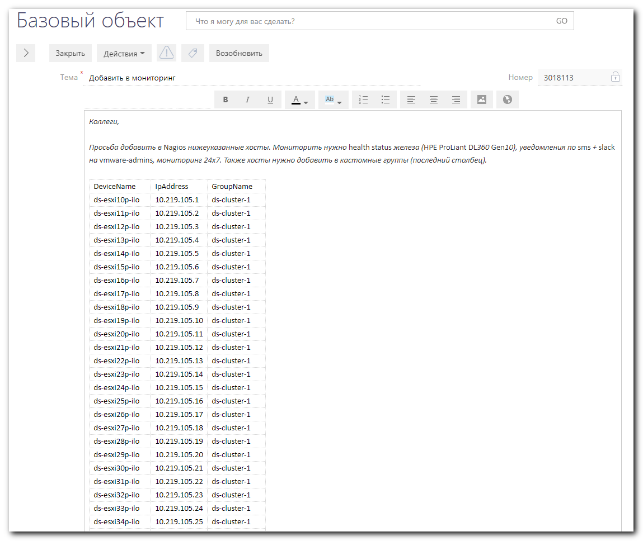

#
# After it was made several servers have unknown status its health.
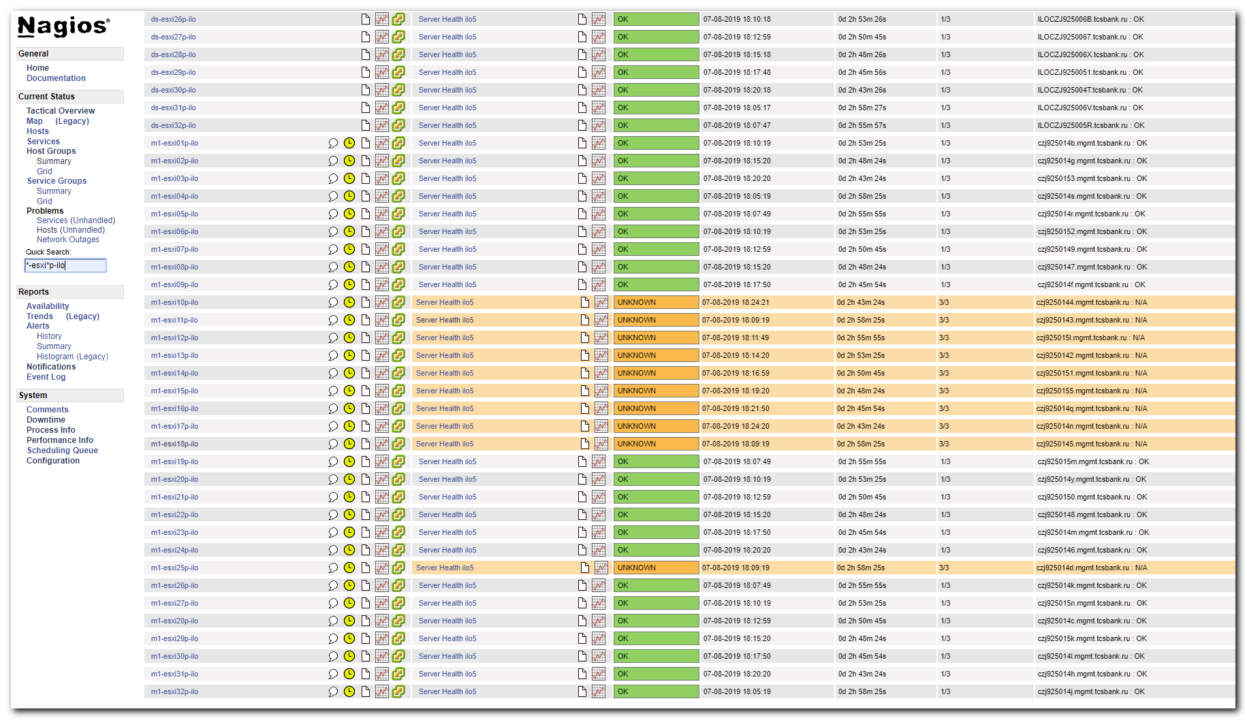

#
# Problem was resolved - it because some servers were not turned on - there were no power on.
#

#
# In follow examples server with iLO 10.219.103.11 has unknown status.
# And server 10.219.103.19 has Ok status.
#
[root@vm-vol-nag4-tst objects]# /usr/local/nagios/libexec/hpeilo_snmp_engine -H 10.219.103.11 -C tcspub -o 1
N/A
[root@vm-vol-nag4-tst objects]# /usr/local/nagios/libexec/hpeilo_snmp_engine -H 10.219.103.19 -C tcspub -o 1
OK
[root@vm-vol-nag4-tst objects]#

[root@vm-vol-nag4-tst objects]# cat /usr/local/nagios/libexec/hpeilo_snmp_engine_heavy_2.sh
#!/bin/bash

# Nagios return codes
STATE_OK=0
STATE_WARNING=1
STATE_CRITICAL=2
STATE_UNKNOWN=3

SN=$(snmpget -O qn -c tcspub -v 2c $1 .1.3.6.1.2.1.1.5.0 | cut -d " " -f 2)
#snmpget -O qn -c tcspub -v 2c $1 .1.3.6.1.2.1.1.5.0 | cut -d " " -f 2
echo -n $SN ": "

/usr/local/nagios/libexec/hpeilo_snmp_engine -H $1 -C tcspub -o 1

/usr/local/nagios/libexec/hpeilo_snmp_engine -H $1 -C tcspub -o 1

exit_code=$?
#echo $?

if [ ${exit_code} -eq 1 ]; then
exit $STATE_CRITICAL
else
exit $exit_code
fi

[root@vm-vol-nag4-tst objects]#

[root@vm-vol-nag4-tst objects]# snmpget -O qn -c tcspub -v 2c 10.219.103.11 .1.3.6.1.2.1.1.5.0
.1.3.6.1.2.1.1.5.0 czj9250143.mgmt.tcsbank.ru
[root@vm-vol-nag4-tst objects]#

[root@vm-vol-nag4-tst objects]# snmpget -O qn -c tcspub -v 2c 10.219.103.19 .1.3.6.1.2.1.1.5.0
.1.3.6.1.2.1.1.5.0 czj925015m.mgmt.tcsbank.ru
[root@vm-vol-nag4-tst objects]#

#
# This binary file was taken from Zabbix.
# Here is its source code
# https://github.com/HewlettPackard/zabbix-plugins-hpeilo/blob/master/src/hpeilo_engine/hpilo_engine.c
#

[root@vm-vol-nag4-tst objects]# file /usr/local/nagios/libexec/hpeilo_snmp_engine
/usr/local/nagios/libexec/hpeilo_snmp_engine: ELF 64-bit LSB executable, x86-64, version 1 (SYSV), dynamically linked (uses shared libs), for GNU/Linux 2.6.18, stripped
[root@vm-vol-nag4-tst objects]#

[root@vm-vol-nag4-tst objects]# /usr/local/nagios/libexec/hpeilo_snmp_engine -V
hpeilo_snmp_engine version - 1.0
[root@vm-vol-nag4-tst objects]#

[root@vm-vol-nag4-tst objects]# /usr/local/nagios/libexec/hpeilo_snmp_engine --help
Usage: hpeilo_snmp_engine -H <hostname> -C <community> -o <oid> [-V] [-J] [-h]

-H, --hostname=ip_address
Host name or IP address to connect with
-C, --community=SNMP_COMMINUTY
SNMP comminuty string. For example: -C public or --community=public
-o, --oid=oid_index
OID index

oid index OID info
------------------------------------
0 System Health Array
1 System Health
2 Fans
3 Memory
4 Network
5 Power Supplies [996/4969]
6 Processors
7 Storage
8 Temperatures
9 Fan Redundancy
10 Power Redundancy
11 Host OS
------------------------------------
-J, --json
print the oid data in json format

oid index OID info
------------------------------------
0 System Health Array
1 System Health
2 Fans
3 Memory
4 Network
5 Power Supplies
6 Processors
7 Storage
8 Temperatures
9 Fan Redundancy
10 Power Redundancy
11 Host OS
------------------------------------
-V, --version
print the version number
-h, --help
print this help menu
[root@vm-vol-nag4-tst objects]#

[root@vm-vol-nag4-tst objects]# snmpwalk -v 2c -c tcspub 10.219.103.19 .1 | less
[root@vm-vol-nag4-tst objects]# snmpwalk -v 2c -c tcspub 10.219.103.11 .1 | less

[root@vm-vol-nag4-tst objects]# snmpwalk -v 2c -c tcspub 10.219.103.11
SNMPv2-MIB::sysDescr.0 = STRING: Integrated Lights-Out 5 1.45 Jun 27 2019
SNMPv2-MIB::sysObjectID.0 = OID: SNMPv2-SMI::enterprises.232.9.4.11
DISMAN-EVENT-MIB::sysUpTimeInstance = Timeticks: (43948) 0:07:19.48
SNMPv2-MIB::sysContact.0 = STRING: vmware-admins@tinkoff.ru
SNMPv2-MIB::sysName.0 = STRING: czj9250143.mgmt.tcsbank.ru
SNMPv2-MIB::sysLocation.0 = STRING: M1.V321-4.U40

[root@vm-vol-nag4-tst objects]# snmpwalk -v 2c -c tcspub 10.219.103.19
SNMPv2-MIB::sysDescr.0 = STRING: Integrated Lights-Out 5 1.45 Jun 27 2019
SNMPv2-MIB::sysObjectID.0 = OID: SNMPv2-SMI::enterprises.232.9.4.11
DISMAN-EVENT-MIB::sysUpTimeInstance = Timeticks: (1899792716) 219 days, 21:12:07.16
SNMPv2-MIB::sysContact.0 = STRING: vmware-admins@tinkoff.ru
SNMPv2-MIB::sysName.0 = STRING: czj925015m.mgmt.tcsbank.ru
SNMPv2-MIB::sysLocation.0 = STRING: M1.V321-5.U41
[root@vm-vol-nag4-tst objects]#

#
# Here I understood, that software use port 161 and return “N/A” string.
# And here I’ve not found any significant errrors.
#
[root@vm-vol-nag4-tst objects]# strace /usr/local/nagios/libexec/hpeilo_snmp_engine -H 10.219.103.11 -C tcspub -o 1
execve("/usr/local/nagios/libexec/hpeilo_snmp_engine", ["/usr/local/nagios/libexec/hpeilo"..., "-H", "10.219.103.11", "-C", "tcspub", "-o", "1"], [/* 28 vars */]) = 0
brk(0)
...
sendmsg(3, {msg_name(16)={sa_family=AF_INET, sin_port=htons(161), sin_addr=inet_addr("10.219.103.11")}, msg_iov(1)=[{"0,\2\1\1\4\6tcspub\245\37\2\4G:!\354\2\1\0\2\1\n0\0210\17\6"..., 46}], msg_cont
rollen=32, {cmsg_len=28, cmsg_level=SOL_IP, cmsg_type=, ...}, msg_flags=0}, MSG_DONTWAIT|MSG_NOSIGNAL) = 46
select(4, [3], NULL, NULL, {2, 999975}) = 1 (in [3], left {2, 996443})
brk(0xdc8000) = 0xdc8000
recvmsg(3, {msg_name(16)={sa_family=AF_INET, sin_port=htons(161), sin_addr=inet_addr("10.219.103.11")}, msg_iov(1)=[{"0\201\243\2\1\1\4\6tcspub\242\201\225\2\4G:!\354\2\1\0\2\1\0000\201\206"..., 65
536}], msg_controllen=0, msg_flags=0}, MSG_DONTWAIT) = 166
brk(0xdb8000) = 0xdb8000
fstat(1, {st_mode=S_IFCHR|0620, st_rdev=makedev(136, 6), ...}) = 0
mmap(NULL, 4096, PROT_READ|PROT_WRITE, MAP_PRIVATE|MAP_ANONYMOUS, -1, 0) = 0x7f1469c79000
write(1, "N/A\n", 4N/A
) = 4
close(3) = 0
exit_group(3) = ?
+++ exited with 3 +++
[root@vm-vol-nag4-tst objects]#

[root@vm-vol-nag4-tst objects]# snmpget -O qn -c tcspub -v 2c 10.219.103.19 .1.3.6.1.4.1.232.11.2.14.1.1.1.1
.1.3.6.1.4.1.232.11.2.14.1.1.1.1 1
[root@vm-vol-nag4-tst objects]# snmpget -O qn -c tcspub -v 2c 10.219.103.19 .1.3.6.1.4.1.232.11.2.14.1.1.1.2
.1.3.6.1.4.1.232.11.2.14.1.1.1.2 2
[root@vm-vol-nag4-tst objects]#

[root@vm-vol-nag4-tst objects]# tcpdump -v -i any host 10.219.103.11 and port 161
tcpdump: listening on any, link-type LINUX_SLL (Linux cooked), capture size 65535 bytes
16:27:51.145661 IP (tos 0x0, ttl 64, id 0, offset 0, flags [DF], proto UDP (17), length 71)
vm-vol-nag01t.tcsbank.ru.60060 > czj9250143.mgmt.tcsbank.ru.snmp: { SNMPv2c C=tcspub { GetRequest(28) R=1155946828 system.sysName.0 } }
16:27:51.147487 IP (tos 0x0, ttl 61, id 34252, offset 0, flags [none], proto UDP (17), length 97)
czj9250143.mgmt.tcsbank.ru.snmp > vm-vol-nag01t.tcsbank.ru.60060: { SNMPv2c C=tcspub { GetResponse(54) R=1155946828 system.sysName.0="czj9250143.mgmt.tcsbank.ru" } }
16:28:06.235214 IP (tos 0x0, ttl 64, id 0, offset 0, flags [DF], proto UDP (17), length 74)
vm-vol-nag01t.tcsbank.ru.47739 > czj9250143.mgmt.tcsbank.ru.snmp: { SNMPv2c C=tcspub { GetBulk(31) R=1742189343 N=0 M=10 E:232.11.2.10.7 } }
16:28:06.237519 IP (tos 0x0, ttl 61, id 34253, offset 0, flags [none], proto UDP (17), length 194)
czj9250143.mgmt.tcsbank.ru.snmp > vm-vol-nag01t.tcsbank.ru.47739: { SNMPv2c C=tcspub { GetResponse(149) R=1742189343 E:232.11.2.10.7.0=00_00_02_01_02_01_02_02_02_02_00_02_00_00_01_02_02_01_0$_00_00_00_00_00_00_00_00_00_00_00_00_00 E:232.11.2.14.1.1.1.0=0 E:232.11.2.14.1.1.1.1=1 E:232.11.2.14.1.1.1.2=2 E:232.11.2.14.1.1.1.3=3 } }

4 packets captured
4 packets received by filter
0 packets dropped by kernel
[root@vm-vol-nag4-tst objects]#

[root@vm-vol-nag4-tst objects]# /usr/local/nagios/libexec/hpeilo_snmp_engine -H 10.219.103.11 -C tcspub -o 1
N/A
[root@vm-vol-nag4-tst objects]# /usr/local/nagios/libexec/hpeilo_snmp_engine -H 10.219.103.19 -C tcspub -o 1
OK
[root@vm-vol-nag4-tst objects]#

[root@vm-vol-nag4-tst objects]# tcpdump -v -i any host 10.219.103.11 or host 10.219.103.19 and port 161 -w /var/tmp/20190807-1630.tcpdump.to.ilo.dat
tcpdump: listening on any, link-type LINUX_SLL (Linux cooked), capture size 65535 bytes
4 packets captured
4 packets received by filter
0 packets dropped by kernel
[root@vm-vol-nag4-tst objects]#

[root@vm-vol-nag4-tst objects]# tshark -r /var/tmp/20190807-1630.tcpdump.to.ilo.dat -V | less
[root@vm-vol-nag4-tst objects]# tshark -r /var/tmp/20190807-1630.tcpdump.to.ilo.dat -V | vim -

#
# Only follow difference was found during compare returned packets from two hosts.
#

# Here is “N/A” host.
[root@vm-vol-nag4-tst objects]# snmpget -O qn -c tcspub -v 2c 10.219.103.11 .1.3.6.1.4.1.232.11.2.10.7.0
.1.3.6.1.4.1.232.11.2.10.7.0 "00 00 02 01 02 01 02 02 02 02 00 02 00 00 01 02
02 01 00 00 00 00 00 00 00 00 00 00 00 00 00 00 "
[root@vm-vol-nag4-tst objects]#

# Here are “Ok” hosts.
[root@vm-vol-nag4-tst objects]# snmpget -O qn -c tcspub -v 2c 10.219.103.19 .1.3.6.1.4.1.232.11.2.10.7.0
.1.3.6.1.4.1.232.11.2.10.7.0 "02 02 02 02 02 02 02 02 02 02 00 02 00 00 01 02
02 02 00 00 00 00 00 00 00 00 00 00 00 00 00 00 "
[root@vm-vol-nag4-tst objects]#
[root@vm-vol-nag4-tst objects]# snmpget -O qn -c tcspub -v 2c 10.219.103.20 .1.3.6.1.4.1.232.11.2.10.7.0
.1.3.6.1.4.1.232.11.2.10.7.0 "02 02 02 02 02 02 02 02 02 02 00 02 00 00 01 02
02 02 00 00 00 00 00 00 00 00 00 00 00 00 00 00 "
[root@vm-vol-nag4-tst objects]# snmpget -O qn -c tcspub -v 2c 10.219.103.21 .1.3.6.1.4.1.232.11.2.10.7.0
.1.3.6.1.4.1.232.11.2.10.7.0 "02 04 02 02 02 02 02 04 02 02 00 02 00 00 01 02
02 02 00 00 00 00 00 00 00 00 00 00 00 00 00 00 "
[root@vm-vol-nag4-tst objects]#

